**PANDA FUR BREAKDOWN**

Highlighted filepaths denote that they are maintained in a separate mesh folder.

**CI_pan_fac_naked**

···p··8  
Game/Character/Item/CharacterItem/PAN/FACE/CI_pan_fac_naked

Game/Character/Item/Meshes/pan/Face/pan_fac_naked/Material/MI_NeoFur_pan_naked

Game/Character/Item/Meshes/pan/Face/pan_fac_naked/Meshes/SK_CH_pan_fac_naked

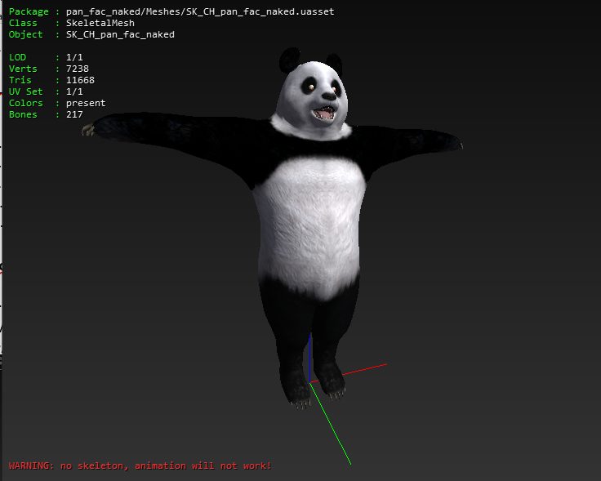 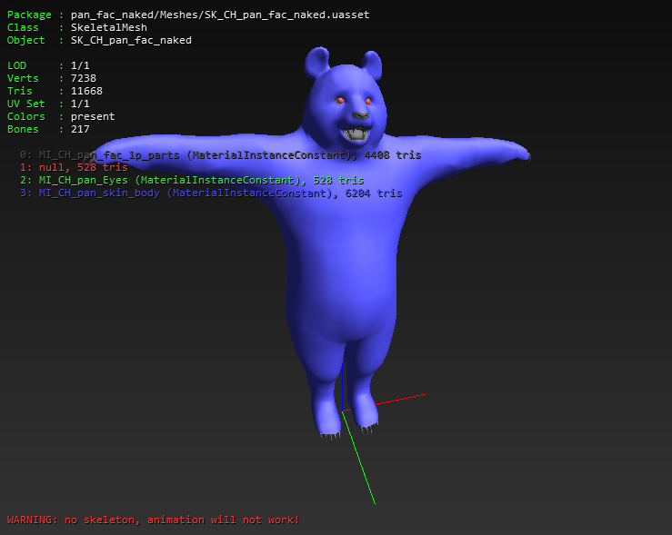

Game/Character/Item/Meshes/pan/Face/pan_fac_naked/Meshes/SK_CH_pan_fac_naked_pom

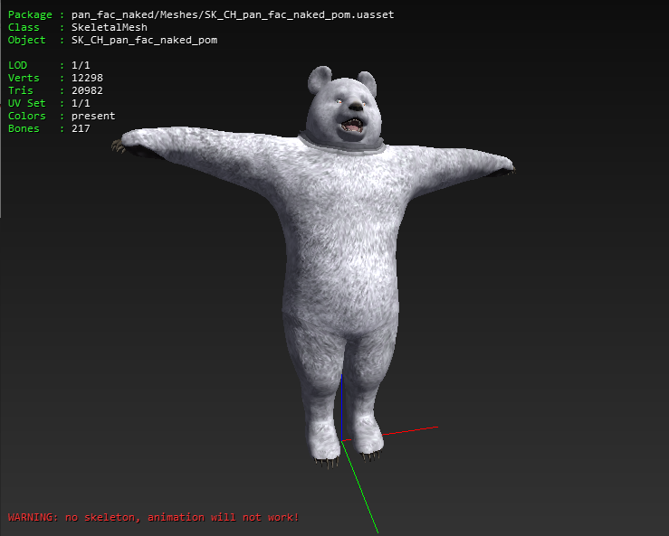 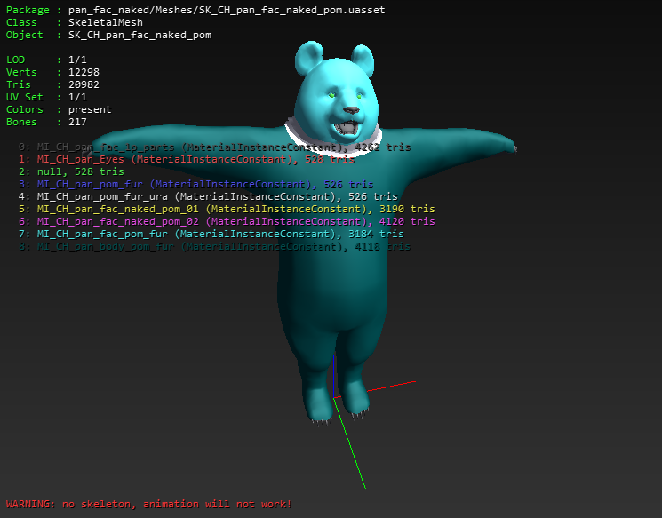

Game/Character/Item/Meshes/pan/Face/pan_fac_naked/NF_pan_naked

**MI_NeoFur_pan_naked**

Game/Character/Common/shader/Material/M_CH_Neofur

Game/Character/Item/Meshes/kum/Face/kum_fac/Texture/T_CH_kum_fur_noise01

Game/Character/Item/Meshes/pan/Face/pan_fac_1p/Texture/T_CH_pan_fac_1p_D

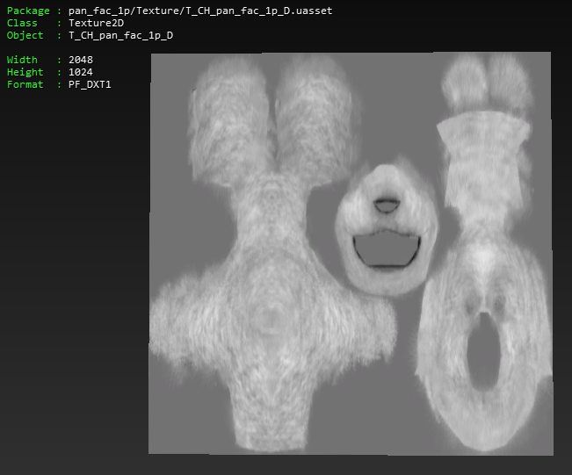

Game/Character/Item/Meshes/pan/Face/pan_fac_1p/Texture/T_CH_pan_fac_1p_M

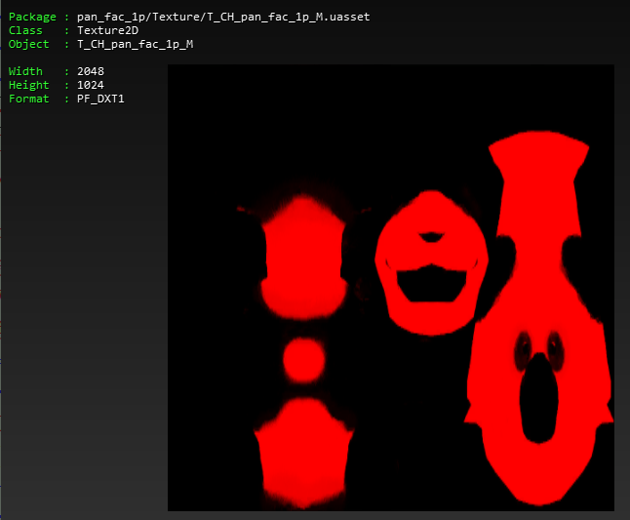

Game/Character/Item/Meshes/pan/Face/pan_fac_naked/Material/MI_NeoFur_pan_naked

Game/Character/Item/Meshes/pan/Face/pan_fac_naked/Texture/T_CH_pan_fac_naked_growth

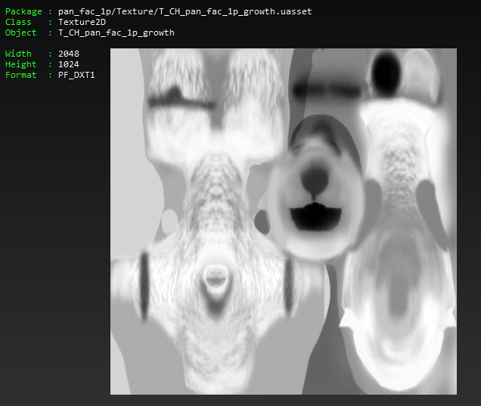

**SK_CH_pan_fac_naked**

Game/Character/Common/Skeleton/SKT_CH_base_Skeleton

Game/Character/Item/Meshes/kum/Face/kum_fac/Material/MI_CH_kum_Eye_ADD

Game/Character/Item/Meshes/pan/Face/pan_fac_1p/Material/MI_CH_pan_fac_1p_parts

Game/Character/Item/Meshes/pan/Face/pan_fac_1p/Material/MI_CH_pan_skin_body

Game/Character/Item/Meshes/pan/Face/pan_fac_naked/Material/MI_CH_pan_Eyes

Game/Character/Item/Meshes/pan/Face/pan_fac_naked/Meshes/SK_CH_pan_fac_naked

**MI_CH_pan_skin_body**

Game/Character/Common/shader/Material/M_CH_KumBase

Game/Character/Item/Meshes/pan/Face/pan_fac_1p/Material/MI_CH_pan_skin_body

Game/Character/Item/Meshes/pan/Face/pan_fac_1p/Texture/T_CH_pan_skin_body_D

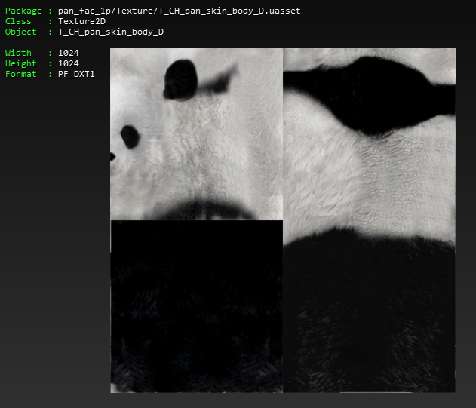

Game/Character/Item/Meshes/pan/Face/pan_fac_1p/Texture/T_CH_pan_skin_body_N

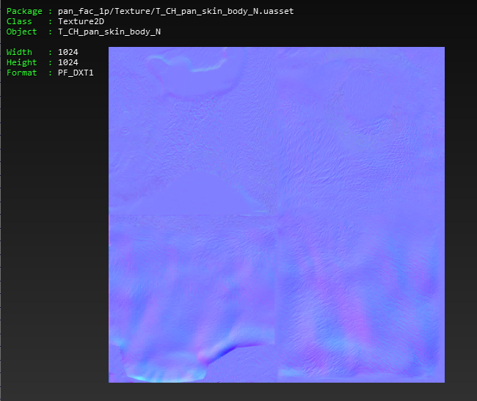

Game/Character/Item/Meshes/pan/Face/pan_fac_1p/Texture/T_CH_pan_skin_body_S

**SK_CH_pan_fac_naked_pom**

Game/Character/Common/Skeleton/SKT_CH_base_Skeleton  
Game/Character/Item/Meshes/kum/Face/kum_fac/Material/MI_CH_kum_Eye_ADD

Game/Character/Item/Meshes/pan/Face/pan_fac_1p/Material/MI_CH_pan_fac_1p_parts

Game/Character/Item/Meshes/pan/Face/pan_fac_naked/Material/MI_CH_pan_body_pom_fur

Game/Character/Item/Meshes/pan/Face/pan_fac_naked/Material/MI_CH_pan_Eyes

Game/Character/Item/Meshes/pan/Face/pan_fac_naked/Material/MI_CH_pan_fac_naked_pom

Game/Character/Item/Meshes/pan/Face/pan_fac_naked/Material/MI_CH_pan_fac_naked_pom_02

Game/Character/Item/Meshes/pan/Face/pan_fac_naked/Material/MI_CH_pan_fac_pom_fur

Game/Character/Item/Meshes/pan/Face/pan_fac_naked/Material/MI_CH_pan_pom_fur

Game/Character/Item/Meshes/pan/Face/pan_fac_naked/Material/MI_CH_pan_pom_fur_ura

Game/Character/Item/Meshes/pan/Face/pan_fac_naked/Meshes/SK_CH_pan_fac_naked_pom

**MI_CH_pan_body_pom_fur**

Game/Character/Common/shader/Material/M_CH_Base_trans

Game/Character/Item/Meshes/pan/Face/pan_fac_naked/Material/MI_CH_pan_body_pom_fur

Game/Character/Item/Meshes/pan/Face/pan_fac_naked/Texture/T_CH_pan_fac_naked_pom_02_fur_D

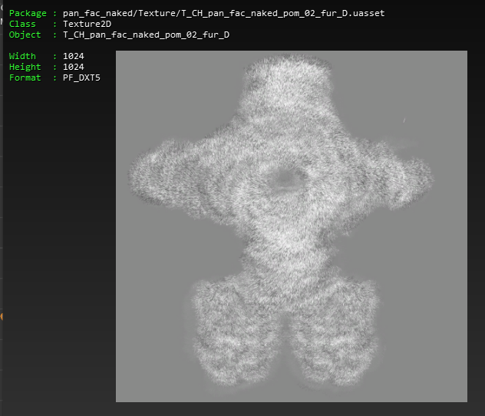

Game/Character/Item/Meshes/pan/Face/pan_fac_naked/Texture/T_CH_pan_fac_naked_pom_02_M

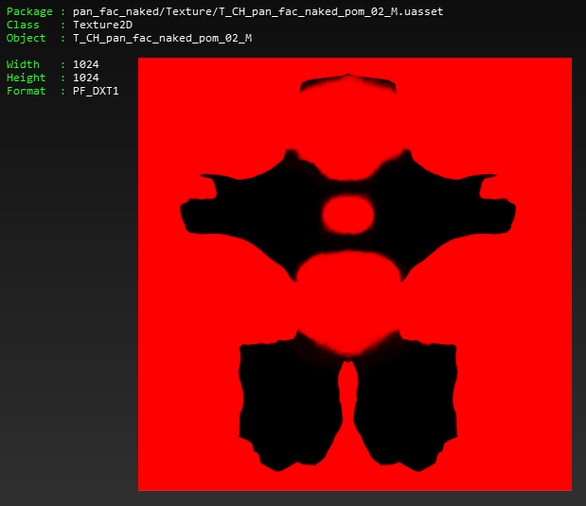

Game/Character/Item/Meshes/pan/Face/pan_fac_naked/Texture/T_CH_pan_fac_naked_pom_02_N

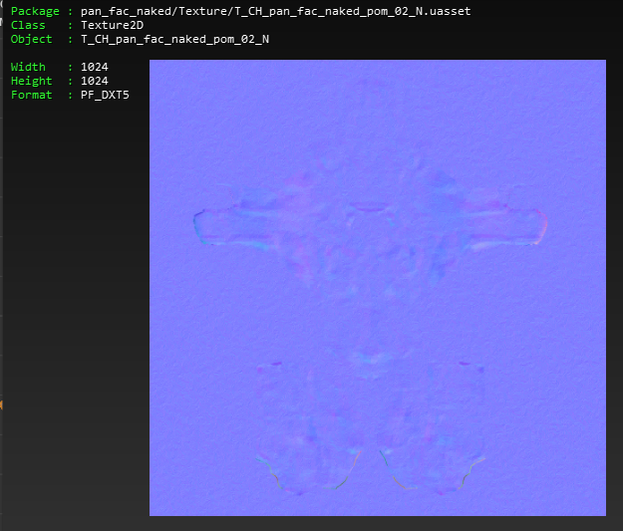

**MI_CH_pan_fac_naked_pom_01**

Game/Character/Common/shader/Material/M_CH_POM

Game/Character/Common/shader/Texture/T_CH_transbase_D

Game/Character/Item/Meshes/pan/Face/pan_fac_naked/Material/MI_CH_pan_fac_naked_pom_01

Game/Character/Item/Meshes/pan/Face/pan_fac_naked/Texture/T_CH_pan_fac_naked_pom_01_D

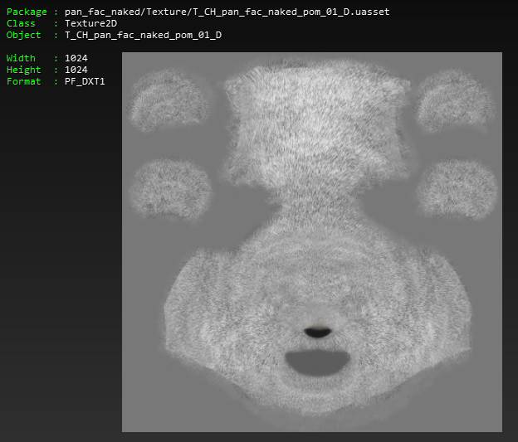

Game/Character/Item/Meshes/pan/Face/pan_fac_naked/Texture/T_CH_pan_fac_naked_pom_01_hight

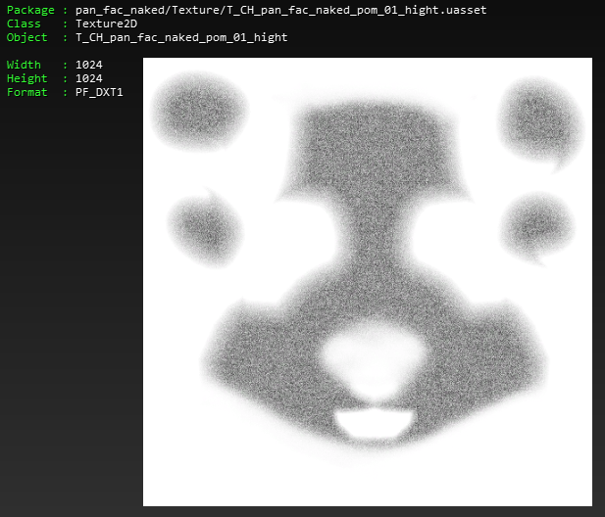

Game/Character/Item/Meshes/pan/Face/pan_fac_naked/Texture/T_CH_pan_fac_naked_pom_01_M

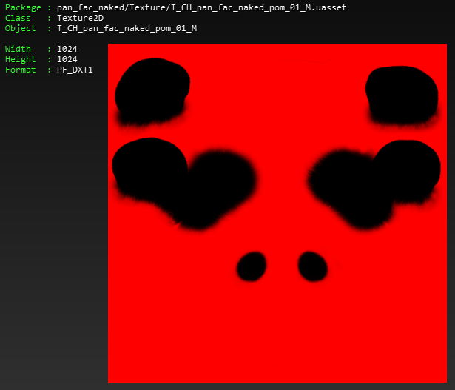

Game/Character/Item/Meshes/pan/Face/pan_fac_naked/Texture/T_CH_pan_fac_naked_pom_01_N

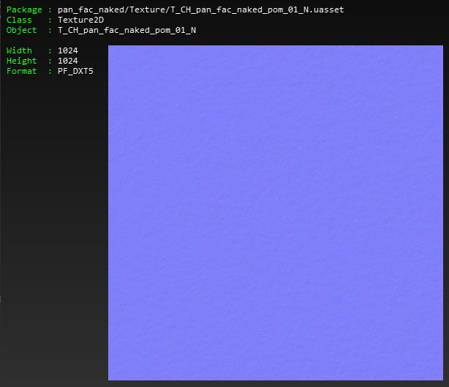

Game/Character/Item/Meshes/pan/Face/pan_fac_naked/Texture/T_CH_pan_fac_naked_pom_01_R

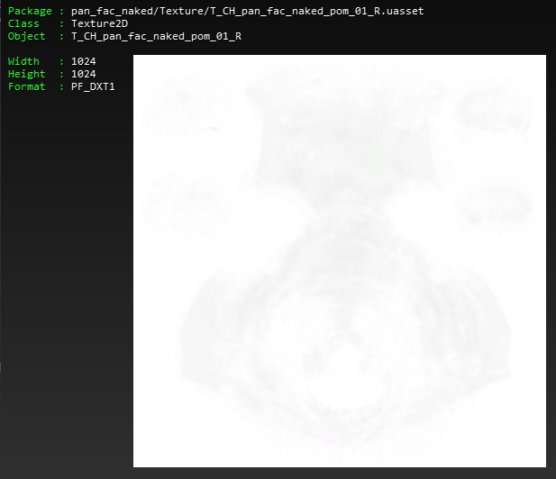

**MI_CH_pan_fac_naked_pom_02**

Game/Character/Common/shader/Material/M_CH_POM

Game/Character/Common/shader/Texture/T_CH_transbase_D

Game/Character/Item/Meshes/pan/Face/pan_fac_naked/Material/MI_CH_pan_fac_naked_pom_02

Game/Character/Item/Meshes/pan/Face/pan_fac_naked/Texture/T_CH_pan_fac_naked_pom_02_D

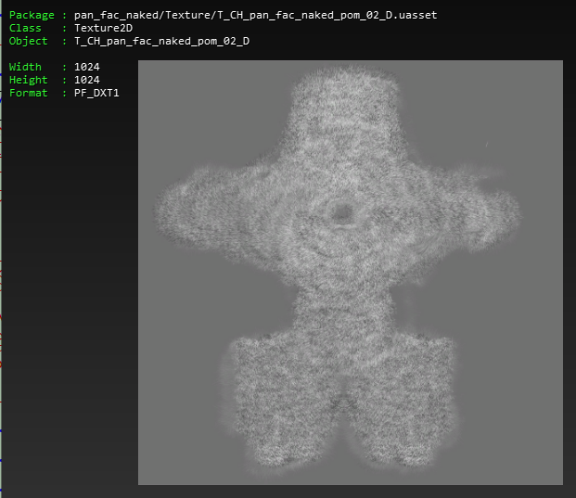

Game/Character/Item/Meshes/pan/Face/pan_fac_naked/Texture/T_CH_pan_fac_naked_pom_02_hight

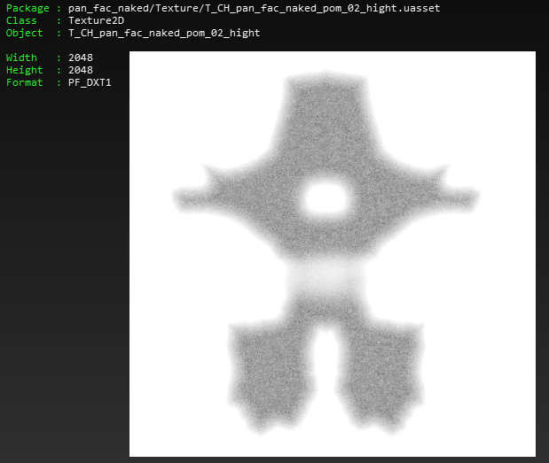

Game/Character/Item/Meshes/pan/Face/pan_fac_naked/Texture/T_CH_pan_fac_naked_pom_02_M

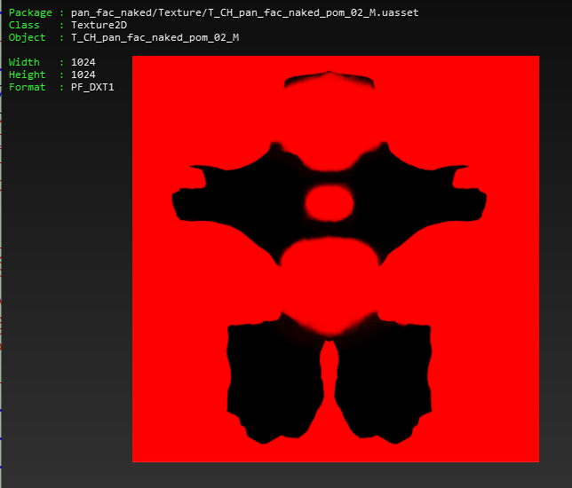

Game/Character/Item/Meshes/pan/Face/pan_fac_naked/Texture/T_CH_pan_fac_naked_pom_02_N

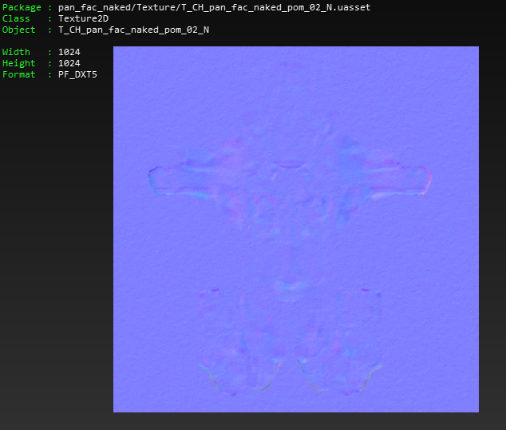

Game/Character/Item/Meshes/pan/Face/pan_fac_naked/Texture/T_CH_pan_fac_naked_pom_02_R

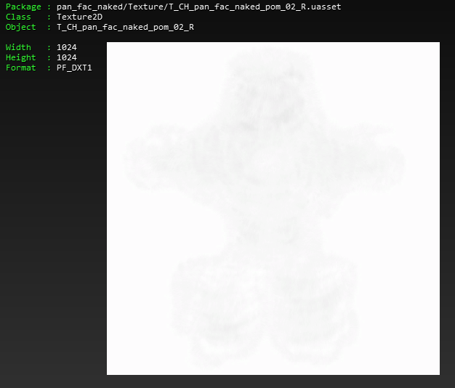

**MI_CH_pan_fac_pom_fur**

Game/Character/Common/shader/Material/M_CH_Base_trans

Game/Character/Item/Meshes/pan/Face/pan_fac_naked/Material/MI_CH_pan_fac_pom_fur

Game/Character/Item/Meshes/pan/Face/pan_fac_naked/Texture/T_CH_pan_fac_naked_pom_01_fur_D

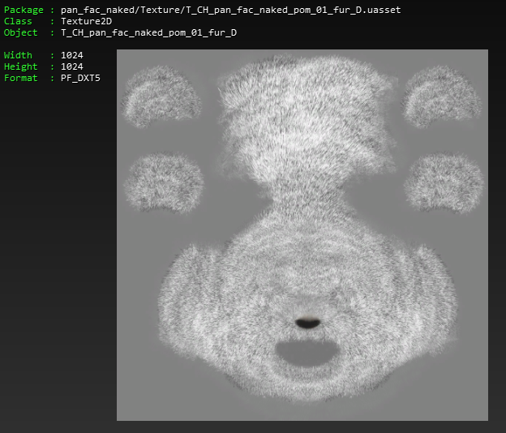

Game/Character/Item/Meshes/pan/Face/pan_fac_naked/Texture/T_CH_pan_fac_naked_pom_01_M

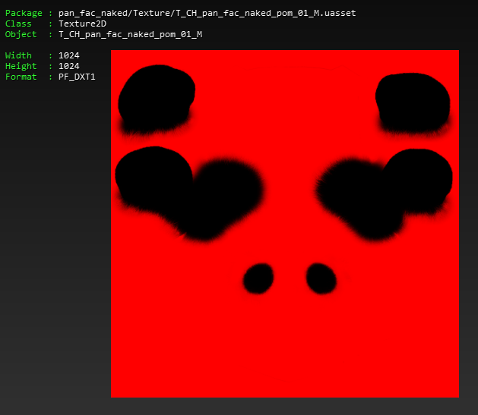

Game/Character/Item/Meshes/pan/Face/pan_fac_naked/Texture/T_CH_pan_fac_naked_pom_01_N

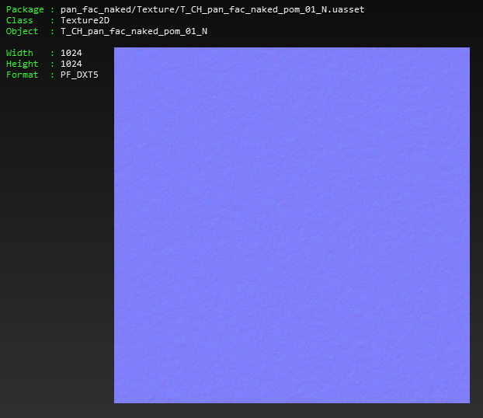

**MI_CH_pan_pom_fur**

Game/Character/Common/shader/Material/M_CH_Base_Sub_dither

Game/Character/Common/shader/Texture/T_CH_transbase_D

Game/Character/Item/Meshes/kum/Face/kum_fac/Texture/T_CH_kum_body_pom_fur_M

Game/Character/Item/Meshes/pan/Face/pan_fac_naked/Material/MI_CH_pan_pom_fur

Game/Character/Item/Meshes/pan/Face/pan_fac_naked/Texture/T_CH_pan_pom_fur_D

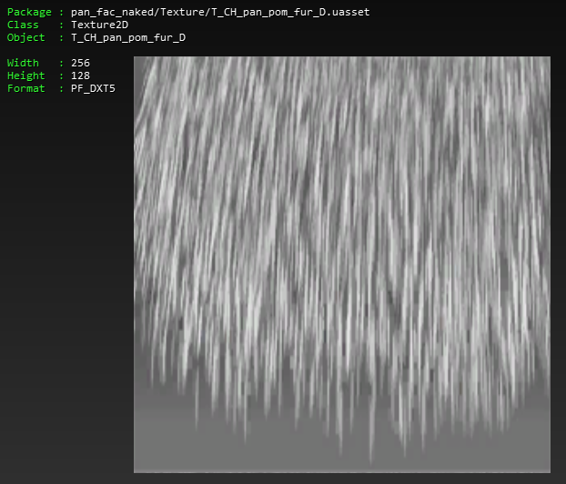

Game/Character/Item/Meshes/pan/Face/pan_fac_naked/Texture/T_CH_pan_pom_fur_N

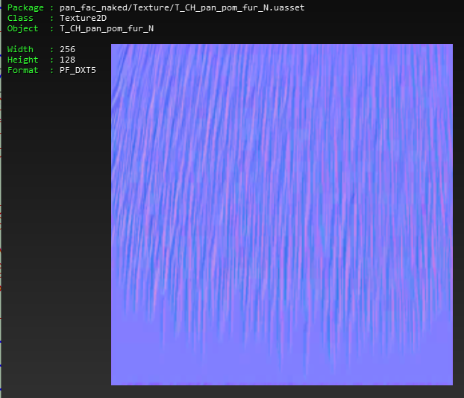

Game/Character/Item/Meshes/pan/Face/pan_fac_naked/Texture/T_CH_pan_pom_fur_sub

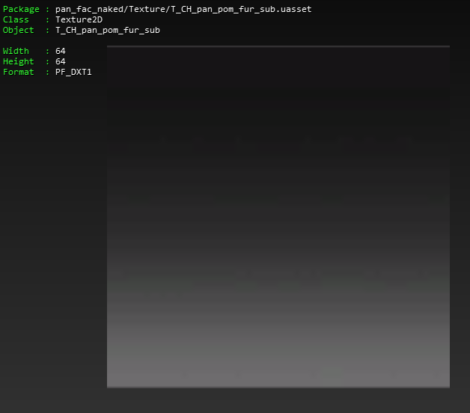

**MI_CH_pan_pom_fur_ura (NECK FUR)**

Game/Character/Common/shader/Material/M_CH_Base_Sub_dither

Game/Character/Common/shader/Texture/T_CH_transbase_D

Game/Character/Item/Meshes/kum/Face/kum_fac/Texture/T_CH_kum_body_pom_fur_M

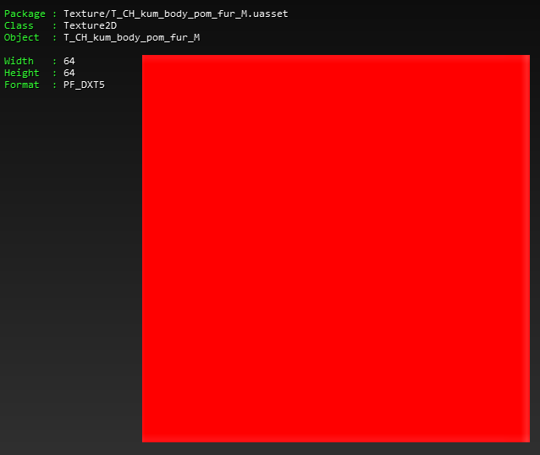

Game/Character/Item/Meshes/kum/Face/kum_fac/Texture/T_CH_kum_pom_fur_sub_ura

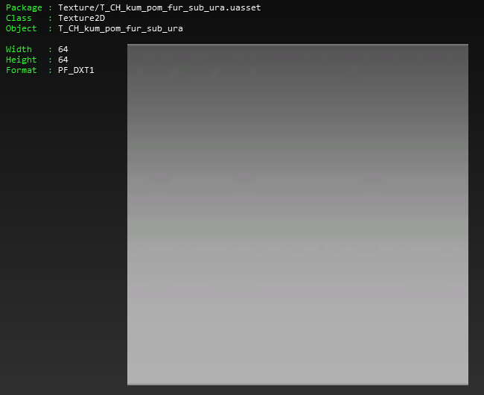

Game/Character/Item/Meshes/pan/Face/pan_fac_naked/Material/MI_CH_pan_pom_fur_ura

Game/Character/Item/Meshes/pan/Face/pan_fac_naked/Texture/T_CH_pan_pom_fur_D



Game/Character/Item/Meshes/pan/Face/pan_fac_naked/Texture/T_CH_pan_pom_fur_N



**NF_pan_naked**

Game/Character/Item/Meshes/pan/Face/pan_fac_naked/Meshes/SK_CH_pan_fac_naked_growth

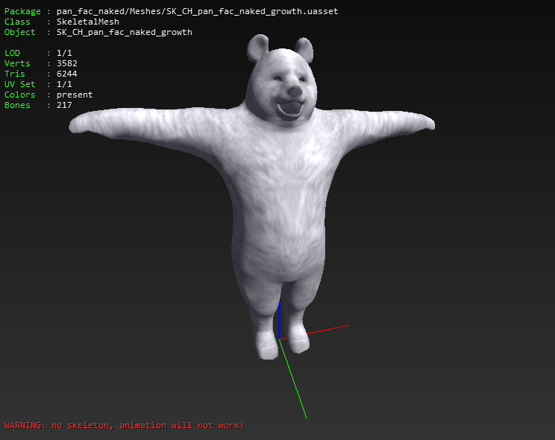 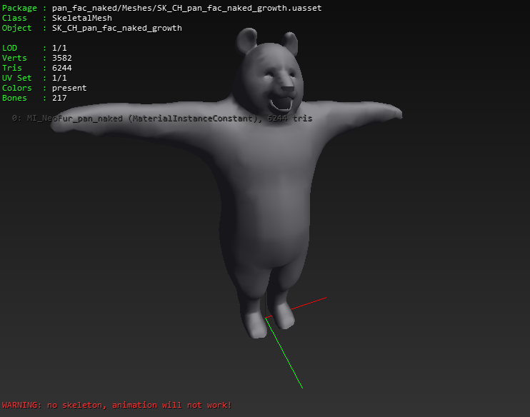

Game/Character/Item/Meshes/pan/Face/pan_fac_naked/NF_pan_naked

**SK_CH_pan_fac_naked_growth**

Game/Character/Common/Skeleton/SKT_CH_base_Skeleton

Game/Character/Item/Meshes/pan/Face/pan_fac_naked/Material/MI_NeoFur_pan_naked

Game/Character/Item/Meshes/pan/Face/pan_fac_naked/Meshes/SK_CH_pan_fac_naked_growth

**MI_NeoFur_pan_naked**

Game/Character/Common/shader/Material/M_CH_Neofur

Game/Character/Item/Meshes/kum/Face/kum_fac/Texture/T_CH_kum_fur_noise01

Game/Character/Item/Meshes/pan/Face/pan_fac_1p/Texture/T_CH_pan_fac_1p_D

Game/Character/Item/Meshes/pan/Face/pan_fac_1p/Texture/T_CH_pan_fac_1p_M

Game/Character/Item/Meshes/pan/Face/pan_fac_naked/Material/MI_NeoFur_pan_naked

Game/Character/Item/Meshes/pan/Face/pan_fac_naked/Texture/T_CH_pan_fac_naked_growth

*(TEXTURES THE SAME AS SHOWN ABOVE)*

**CI_pan_fac_cat_naked (observation)**

···Š··R  
·················Ž··A···/Game/Character/Item/CharacterItem/PAN/FACE/CI_pan_fac_cat_naked

õ¡R···/Game/Character/Item/Meshes/pan/Face/pan_fac_cat/Material/MI_NeoFur_pan_cat_naked

ú,vP···/Game/Character/Item/Meshes/pan/Face/pan_fac_cat/Meshes/SK_CH_pan_fac_cat_naked

›

‡T···/Game/Character/Item/Meshes/pan/Face/pan_fac_cat/Meshes/SK_CH_pan_fac_naked_pom_cat

{f@···/Game/Character/Item/Meshes/pan/Face/pan_fac_naked/NF_pan_naked

NOTES:

* Each CI has its own MI_NeoFur_xxx variation as well as SK variations.
* All use the basic NF_pan_naked SK